**Title:** Live Laravel back-end api project in Aws Ec2- Instance.

Step1: Open Ec2 and launch instance using option “Launch Instance.” 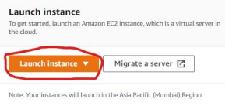

Step2: Give name that instance what you want and select ‘Ubuntu’ OS in “**Application and OS Images (Amazon Machine Image)**” option.

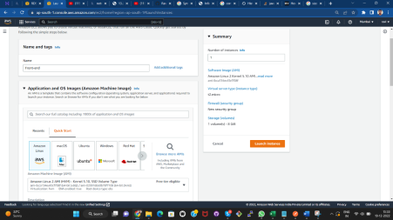

Step3: Select Instance Type (Instance types comprise varying combinations of CPU, memory, storage, and networking capacity and **give you the flexibility to choose the appropriate mix of resources for your applications**.) as per your website requirement, then select “key pair(login)” if you have one,or create new one using “create new key pair” option.

• In some project there is t2.small or t2.medium is required, for now set it on t2.micro and later if there is cmd “php artisan db:seed” is not working and hang the process then just stop the ec2 change the instance from

t2.micro to t2.small or t2.medium and start ec2 then apply that cmd it’s works fine.

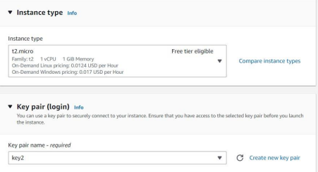

• For how to create keypair see documentation of “Front-end quasar project live” after step3 in it.

Step4:

**Network setting> Firewall (security groups)** select “**Create security group**” if you don’t have one or if you already created security group select “**Select existing security group**” and then select the name of security group you created.

For “**Create security group**” option select check-box of “**Allow SSH traffic from, Allow HTTPS traffic from the internet, Allow HTTP traffic from the internet**”.

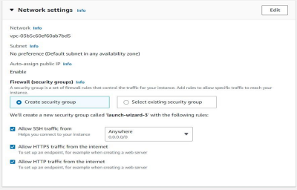

Step5:

In “**Configure Storage”** select size of storage as per limitation of EBS volume type. (Here I take 8gb in **gb2** EBS volume type, which’s limitation is up to 30gb for free tier eligible account.)

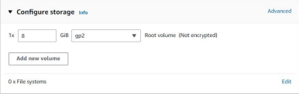

Step6:

Select **“Launch instance”** and launch it.

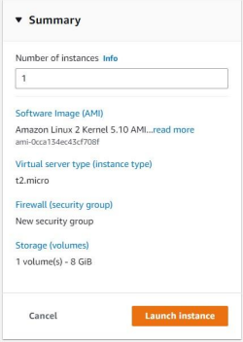

Step7:

Choose “**View all Instances**”

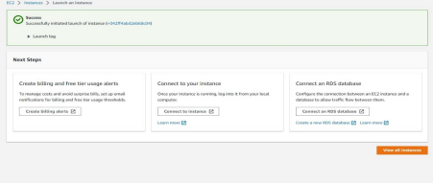Step8:

Choose Option “**Connect**” after the “**Status Checks**” shows “**2/2checks**”. 

Step9:

Choose “**EC2 Instance Connect (browser-based SSH connection)**” and select “Connect” option.

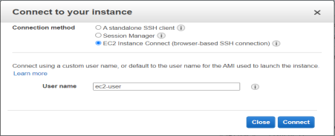

Step 10:

This type of interface is open.

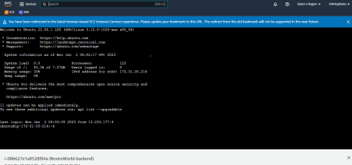Now, first give following cmds :

sudo su

sudo apt-get update

• Create ssh key using following cmd in terminal

ssh-keygen

• Use below shown cmd and then copy “id_rsa.pub” text data which have been shown below:

cat ~/.ssh/id_rsa.pub

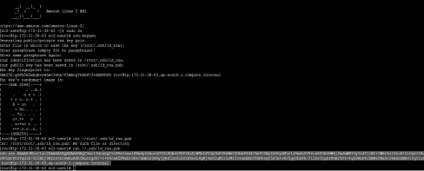

• Paste it in git-hub’s >settings>SSH keys[note:: use this step if new instance is launched(it means not launched using AMIs or snapshot).Also remember it is a one time process,once you add ssh key in github you not have to add every time ssh key when you launch any new project.You just connect your ec2 to this github account using this key once for all. ]

• Paste copied text in there and named it. Then press “Add key”

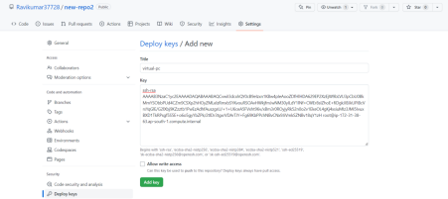Your key is ssh key is now added in git hub repo.

Step 11:

• Give following cmd for activate github repo in ec2.

ssh git@github.com

• Type “yes” in connecting

• Now git hub is successfully connected to your ec2 insatnces.

Step 12:

• Search “Security Groups” open it.

• Select “Create Security group” give name it, add description for that if you want it.

• Select “Add rule” in Inbound rules, in Type select “MYSQL/Aurora” don’t change “Source” and after it select that security group, which is used by ec2 backend-api

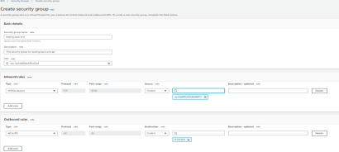• Then select “Create security group”, your group is created.



• Now give it name for your ease of remembering it.



Step13:

• Search “Rds” and open it, select “Create database”.

• Select “Standard create” in first option, then select “MySQL” in Engine Option.



• In “Engine Version” Select latest version of it, in my case it’s “MySQL 8.0.31”

• In Templates select “Free tier”.



• In “Settings” give name to the database in option “DB instance identifier”.



• Give “Master username” and “Master password” also note it down somewhere because we need it later.





• Change “DB instance class” if it’s required for project or leave it as it is. • Change “Storage” according to your project requirement for me its 20Gib.

• Unchecked “Storage autoscaling”.



• Select security group which one you created on step12 in “Existing VPC Security groups” after removing “default” security group.



• In “Additional configuration” give Initial Database name and also note it down somewhere for later it will be required.



• If you want to store automated backup of your database then don’t unchecked “Backup”, in my case I Unchecked it.



• Now, select “Create database” your data-base in Rds is created. Step 14:Import Project in ec2 and connect it with Rds.

• Open Your ec2 instance

• Fire following cmds:

**(note:not use that cmd in which just before cmd i use // )**

sudo su

sudo apt-get update

sudo apt-get install apache2

sudo service apache2 restart

// sudo apt-get install mysql-server

sudo apt-get install php8.1 libapache2-mod-php8.1 php8.1-mysql

// sudo add-apt-repository ppa:ondrej/php8.1

sudo apt-get install php8.1-mcrypt

sudo curl -O https://getcomposer.org/composer.phar

sudo mv composer.phar composer

sudo chmod +x composer

sudo mv composer /usr/local/bin

composer

sudo apt-get install php8.1-mbstring

sudo apt-get install php8.1-xml

sudo apt-get install zip unzip

composer clearcache

cd /var/www/html

• Run your IPv4 address in browser this type of interface is shown.



• Now in your ec2 instance remove index.html file from location /var/www/html and import your working project there by follow following cmds:

cd /var/www/html

rm -rf index.html

git init

git remote add origin (ssh link)

**e.g.**

git remote add origin git@github.com:Ravikumar37728/new-repo2.git

• Now use following cmd for pull codes in ec2 on path var/www/html. git pull origin Master

or

git pull origin main

**NOTE:** main or master or other branch is depended upon which branch code you want to pull from connected git-hub repo.

• Check your code is there or not by using cmd:

ls or ls -la

• Now give following cmd for installing and updating composer composer install --ignore-platform-reqs

composer update --ignore-platform-reqs

* • Change and add data in 000-default.conf for open it, use following cmd: sudo nano /etc/apache2/sites-available/000-default.conf

• Change “DocumentRoot” /var/www/html to “/var/www/html/index.php” or in some project it will be “/var/www/html/public” use one of it, by which one of it project is running (generally second one path is used when in postman,uploaded img’s url gives blank screen in browser. )

• Also add given below data just above the </VirtualHost> in 000-default.conf. <Directory “/var/www/html”>

Options Indexes FollowSymLinks MultiViews

AllowOverride All

Require all granted

</Directory>

**OR**

* • add config file on path /etc/apache2/sites-available/with extension .conf and add data as given below:

<VirtualHost *:80>

ServerName yourdomainname.com

ServerAdmin webmaster@localhost

DocumentRoot /var/www/html/path of your project folder/public

ErrorLog ${APACHE_LOG_DIR}/error.log

CustomLog ${APACHE_LOG_DIR}/access.log combined

<Directory "/var/www/html/">

Options Indexes FollowSymLinks MultiViews

AllowOverride All

Require all granted

</Directory>

</VirtualHost>

• Then enable that file using “a2ensite” cmd for e.g. your config file name is rw.conf then hit cmd::

a2ensite rw.conf

• Using this command allows domain hosts like cloudflare or route53 that, specifically listen on which domain or subdomain projects from single ec2 instance.

• After it restart apache 2 using cmd:

sudo service apache2 restart

• Rename .env.example and named it .env using cmd:

mv .env.example .env

• Fire following cmd:

php artisan cach:clear

php artisan config:clear

php artisan key:generate

• Give read-write permission to the storage and bootstrap sudo chmod 777 -R bootstrap/

sudo chmod 777 -R storage/

sudo service apache2 restart

• Open the .env file and enter DB_HOST, DB_DATABASE, DB_USERNAME, DB_PASSWORD of Rds in there.

• For DB_HOST ,open rds click on your db and open it init in “Connectivity & Security” copy the “Endpoint” link and paste it in DB_Host



• In DB_DATABASE paste name of data base which we save previously in step13,in DB_USERNAME and DB_PASSWORD give Master Username and Master Password which we save previously in step13,and save it. then again one time restart apache2.

• Fire following cmd:

nano /etc/php/8.1/apache2/php.ini

• Change three things in there by finding it in file using Ctrl+Q . upload_max_filesize = 512M

post_max_size = 558M

max_execution_time = 300

• Now fire following cmds:

(NOTE:: use this all cmd if you create any new database first time,if database is moved then only highlighted cmd is in use only)

php artisan migrate:fresh

php artisan passport:install

php artisan key:generate

// php artisan storage:link

php artisan route:cache

php artisan route:clear

php artisan db:seed

• Now, add one line in apache2.conf file for that fire cmd:

sudo nano /etc/apache2/apache2.conf

• Find .htaccess using Ctrl+Q and add given below line on that place which is shown in given figure.

SetEnvIf Authorization "(.*)" HTTP_AUTHORIZATION=$1

• Restart your apache2

sudo service apache2 restart

• Now run your IPv4 address if its redirect to Laravel page it’s means it is live and give path it to api (e.g. 65.24.3.16/api or in some case it is 65.24.3.16/index.php/api) if its redirect to api that means it is working fine.